Please select the link below to download for Original Files to follow the course and participate with the activities.

When you click the file, you may be prompted to a page that looks like the one below. Simply select download.

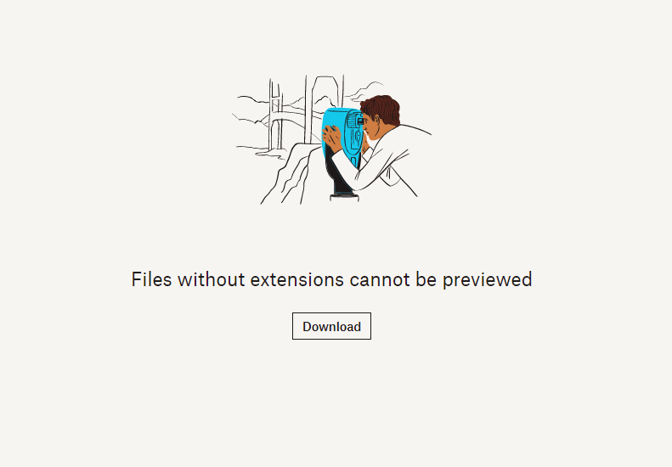

Original files:

https://www.dropbox.com/s/2w68d4egulk1cp8/ECM%20Titanium%20TRUCK%20Training%20-%20DELPHI%20ETC3%20D12_CEDE?dl=0

Please enjoy your course.

Kind regards
Team Remap101.co.uk

e :info@viezu.com
t: +44 (0) 1789 774444

